LIBRARY MANAGEMENT SYSTEM
A MINI-PROJECT REPORT

Submitted by

APARJITHA 241901006
AKSHAYA 241901002
ANGELIN PRAISEE 241901004
ARYA 241901009
AARJUN 241901001
ALAGAPPAN 241901003
BHARATH 241901018
PONSURABHI 241901077
SWARNAMALA 241901116

in partial fulfillment of the award of the degree
of

BACHELOR OF ENGINEERING
IN
COMPUTER SCIENCE AND ENGINEERING
(CYBER SECURITY)

RAJALAKSHMI ENGINEERING COLLEGE, CHENNAI
BONAFIDE CERTIFICATE

Certified that this project “LIBRARY MANAGEMENT SYSTEM” is the bonafide work of “APARAJITHA,AKSHAYA,ANGELIN PRAISEE,ARYA,AARJUN,ALAGAPPAN,BHARATH,

PONSURABHI,SWARNAMALA” who carried out the project
work under my supervision.

SIGNATURE
Dr. FOWZIA SIHANA
ASSISTANT PROFESSOR SG

Dept. of Computer Science and Engg,
Rajalakshmi Engineering College
Chennai

This mini project report is submitted for the viva voce examination to be held on
__________

INTERNAL EXAMINER EXTERNAL EXAMINER

ABSTRACT

The Library Management System is a database-driven
application designed to streamline and automate library operations. This system enables users to view, issue, return, and search books efficiently while maintaining accurate records of members and transactions. Built using Python (CustomTkinter for GUI) and MySQL as the backend, this project demonstrates how databases can be integrated with real-world applications to ensure data consistency, accessibility, and reliability. The system includes functionalities such as viewing available books, issuing and returning books, searching for books, managing members, and tracking overdue items.

ACKNOWLEDGEMENT

We express our sincere thanks to our beloved and honorable chairman MR. S. MEGANATHAN and the chairperson DR. M.THANGAM MEGANATHAN for their timely support and encouragement.
We are greatly indebted to our respected and honorable principal Dr. S.N. MURUGESAN for his able support and guidance.
No words of gratitude will suffice for the unquestioning support extended to
us by our Head Of The Department Dr.BENEDICT JAYAPRAKASH
NICHOLAS for being ever supporting force during our project work
We also extend our sincere and hearty thanks to our internal guide
Dr.FOWZIA SIHANA, for her valuable guidance and motivation during the completion of this project.
Our sincere thanks to our family members, friends and other staff members
of computer science engineering.
- APARAJITHA
- AKSHAYA
- ANGELIN PRAISEE
- ARYA
- AARJUN
- ALAGAPPAN
- BHARATH
- PONSURABHI
- SWARNAMALA

TABLE OF CONTENTS

CHAPTER NO. TITLE PAGE NO
ABSTRACT iv

- INTRODUCTION 7
  - INTRODUCTION 7
  - SCOPE OF THE WORK 7
  - PROBLEM STATEMENT 7
  - AIM AND OBJECTIVES OF THE PROJECT 7
- SYSTEM SPECIFICATIONS 8
  - HARDWARE SPECIFICATIONS 8

2.2 SOFTWARE SPECIFICATIONS 8
- MODULE DESCRIPTION 19
- CODING 10
- SCREENSHOTS 25
- CONCLUSION AND FUTURE ENHANCEMENT 29
REFERENCES 30

LIST OF FIGURES
FIGURE NO. | TITLE | PAGE NO.
5.1 | INTRODUCTION PAGE | 25
5.2 | AVAILABLE BOOKS | 25
5.3 | VIEW MEMBERS | 26
5.4 | SEARCH BOOKS | 26
5.5 | ISSUE BOOK | 27
5.6 | RETURN BOOK | 27
5.7 | ERD | 28

CHAPTER 1
INTRODUCTION
1.1 INTRODUCTION
The Library Management System automates daily tasks like managing books, members, and transactions. Built with Python (CustomTkinter) and MySQL, it replaces manual records with a secure, efficient, and user-friendly interface for issuing, returning, and searching books..
1.2 SCOPE OF THE WORK
This project offers a complete solution for small to medium-sized libraries by digitalizing all records. It automates the management of books and members, enables quick searches, tracks issued and returned books, and minimizes manual errors. The system is scalable and can be upgraded with additional features like online access and fine calculation.
1.3 PROBLEM STATEMENT
Traditional library systems depend on manual recordkeeping, which often results in mismanagement, human errors, and time-consuming operations. A computerized system is necessary to store, update, and retrieve records efficiently and provide real-time data access.
1.4 AIM AND OBJECTIVES OF THE PROJECT
The main aim of this project is to design a user-friendly system that automates and simplifies the management of library operations. It securely stores and manages book and member information, automates the issuing, returning, and searching of books, maintains accurate transaction records, and improves overall efficiency while minimizing human errors.

CHAPTER 2
SYSTEM SPECIFICATIONS
2.1 HARDWARE SPECIFICATIONS
Processor : Intel i5
Memory Size : 8GB (Minimum)
HDD : 1 TB (Minimum)

2.2 SOFTWARE SPECIFICATIONS
Operating System | : | WINDOWS 10 or higher
Front – End | : | Python(CustomTkinter)
Back - End | : | MySql database
Language | : | Python 3
Tools Used | : | MySQL Workbench, VS  Code,python libraries(mysqlconnector,thinker
Libraries | : | mysql-connector, tkinter

CHAPTER 3
MODULE DESCRIPTION
This application consists of two modules. When the program runs, it will ask for a confirmation to the login window. The person who interacts can login as an Administrator or as a User. The description of the modules are as follows:
- Admin login
When the person who interacts tries to login as Admin then he needs to login with his username and password. The administrator only has the power to change and manipulate the data in the database.
- User login
When the person tries to login as a user then he/she will be prompted to enter the number of symptoms and the final result will be printed in the form of table.

CHAPTER 4
SAMPLE CODING FRONTEND CODE
import customtkinter as ctk
from tkinter import messagebox
from backend import (
get_available_books, get_issued_books, search_books,
issue_book, return_book, get_members
)

def clear_frame(main_frame): for widget in main_frame.winfo_children():
widget.destroy()

def display_table(parent, headers, rows):
table_frame = ctk.CTkScrollableFrame(parent, fg_color="white") table_frame.pack(pady=10, padx=20, fill="both", expand=True)

for i, header in enumerate(headers):
label = ctk.CTkLabel(table_frame, text=header, font=("Helvetica",
15, "bold"), text_color="#005f73")
label.grid(row=0, column=i, padx=15, pady=10)

for r_index, row in enumerate(rows, start=1): for c_index, value in enumerate(row):
label = ctk.CTkLabel(table_frame, text=value, font=("Helvetica", 13))
label.grid(row=r_index, column=c_index, padx=15, pady=6)

def create_card(parent, title, desc, button_text, command):
frame = ctk.CTkFrame(parent, corner_radius=15, fg_color="white")
frame.pack_propagate(False)
frame.configure(width=280, height=180)

title_label = ctk.CTkLabel(frame, text=title, font=("Helvetica", 17,
"bold"), text_color="#005f73")
title_label.pack(pady=(15, 5))

desc_label = ctk.CTkLabel(frame, text=desc, font=("Helvetica", 13), text_color="black", wraplength=220)
desc_label.pack(pady=(0, 10))

btn = ctk.CTkButton(frame, text=button_text, width=100, height=30, fg_color="#0a9396",
hover_color="#007f7b", command=command)
btn.pack(pady=(5, 10))
return frame

def available_books_page(main_frame, back_to_home):
clear_frame(main_frame)
ctk.CTkLabel(main_frame, text=" Available Books",
font=("Helvetica", 22, "bold")).pack(pady=15)
rows = get_available_books()
display_table(main_frame, ["Book ID", "Title", "Author", "Genre",
"Year"], rows)
ctk.CTkButton(main_frame, text="⬅ Back to Home", fg_color="#0a9396", command=back_to_home).pack(pady=20)

def issued_books_page(main_frame, back_to_home):
clear_frame(main_frame)
ctk.CTkLabel(main_frame, text=" Issued Books", font=("Helvetica",
22, "bold")).pack(pady=15)
rows = get_issued_books()
display_table(main_frame, ["Issue ID", "Book Title", "Member Name", "Issue Date", "Due Date"], rows)
ctk.CTkButton(main_frame, text="⬅ Back to Home", fg_color="#0a9396", command=back_to_home).pack(pady=20)

def search_books_page(main_frame, back_to_home): clear_frame(main_frame)
ctk.CTkLabel(main_frame, text=" Search Books", font=("Helvetica",
22, "bold")).pack(pady=10)

search_frame = ctk.CTkFrame(main_frame)
search_frame.pack(pady=10)

search_entry = ctk.CTkEntry(search_frame, width=300, placeholder_text="Enter title or author...")
search_entry.grid(row=0, column=0, padx=10)

result_frame = ctk.CTkFrame(main_frame)
result_frame.pack(fill="both", expand=True, pady=10)

def search_action(): for widget in result_frame.winfo_children():
widget.destroy()
term = search_entry.get().strip()
if not term:
messagebox.showwarning("Empty", "Please enter a search term.")
return
rows = search_books(term)
display_table(result_frame, ["Book ID", "Title", "Author",
"Genre", "Year"], rows)

ctk.CTkButton(search_frame, text="Search", fg_color="#0a9396", command=search_action).grid(row=0, column=1, padx=10)
ctk.CTkButton(main_frame, text="⬅ Back to Home", fg_color="#0a9396", command=back_to_home).pack(side="bottom", pady=20)

def issue_book_page(main_frame, back_to_home):
clear_frame(main_frame)
ctk.CTkLabel(main_frame, text=" Issue Book", font=("Helvetica",
22, "bold")).pack(pady=15)

frame = ctk.CTkFrame(main_frame)
frame.pack(pady=20)

book_entry = ctk.CTkEntry(frame, width=200, placeholder_text="Book ID")
book_entry.grid(row=0, column=0, padx=10)
member_entry = ctk.CTkEntry(frame, width=200, placeholder_text="Member ID")
member_entry.grid(row=0, column=1, padx=10)

def issue_action():
success, msg = issue_book(book_entry.get(), member_entry.get())
if success:
messagebox.showinfo("Success", msg)
else:
messagebox.showwarning("Error", msg)

ctk.CTkButton(frame, text="Issue", fg_color="#0a9396", command=issue_action).grid(row=1, column=0, columnspan=2, pady=10)
ctk.CTkButton(main_frame, text="⬅ Back to Home", fg_color="#0a9396", command=back_to_home).pack(side="bottom", pady=20)

def return_book_page(main_frame, back_to_home): clear_frame(main_frame)
ctk.CTkLabel(main_frame, text="🔁 Return Book", font=("Helvetica", 22, "bold")).pack(pady=15)
frame = ctk.CTkFrame(main_frame)
frame.pack(pady=20)
entry = ctk.CTkEntry(frame, width=300, placeholder_text="Enter Issue ID")
entry.grid(row=0, column=0, padx=10)

def return_action():
success, msg = return_book(entry.get())
if success:
messagebox.showinfo("Success", msg)
else:
messagebox.showwarning("Error", msg)

ctk.CTkButton(frame, text="Return", fg_color="#0a9396", command=return_action).grid(row=0, column=1, padx=10)
ctk.CTkButton(main_frame, text="⬅ Back to Home", fg_color="#0a9396", command=back_to_home).pack(side="bottom", pady=20)

def view_members_page(main_frame, back_to_home): clear_frame(main_frame)
ctk.CTkLabel(main_frame, text="View Members", font=("Helvetica", 22, "bold")).pack(pady=20)
rows = get_members()
if rows:
display_table(main_frame, ["Member ID", "Name", "Email",
"Phone"], rows)
else:
ctk.CTkLabel(main_frame, text="No members found.", font=("Helvetica", 14)).pack(pady=20)
ctk.CTkButton(main_frame, text="⬅ Back to Home", fg_color="#0a9396", command=back_to_home).pack(side="bottom", pady=20)

BACKEND CODE
import mysql.connector

def connect_db():
return mysql.connector.connect(
host="localhost",
user="root",
password="Angelin@2006",
database="library_db"
)

def get_available_books(): conn = connect_db()
cur = conn.cursor()
cur.execute("""
SELECT book_id, title, author, genre, year
FROM books
WHERE book_id NOT IN (SELECT book_id FROM issued_books WHERE return_date IS NULL)
""")
rows = cur.fetchall()
conn.close()
return rows

def get_issued_books(): conn = connect_db()
cur = conn.cursor()
cur.execute("""
SELECT i.issue_id, b.title, m.name, i.issue_date, i.due_date
FROM issued_books i
JOIN books b ON i.book_id = b.book_id
JOIN members m ON i.member_id = m.member_id
WHERE i.return_date IS NULL
""")
rows = cur.fetchall()
conn.close()
return rows

def search_books(term): conn = connect_db()
cur = conn.cursor()
cur.execute("""
SELECT book_id, title, author, genre, year
FROM books
WHERE title LIKE %s OR author LIKE %s
""", (f"%{term}%", f"%{term}%"))
rows = cur.fetchall()
conn.close()
return rows

def issue_book(book_id, member_id):
conn = connect_db()
cur = conn.cursor()
cur.execute("SELECT * FROM issued_books WHERE book_id=%s AND return_date IS NULL", (book_id,))
if cur.fetchone(): conn.close()
return False, "Book already issued."

cur.execute("""
INSERT INTO issued_books (book_id, member_id, issue_date, due_date)
VALUES (%s, %s, CURDATE(), DATE_ADD(CURDATE(),
INTERVAL 14 DAY))
""", (book_id, member_id))
conn.commit()
conn.close()
return True, "Book issued successfully."

def return_book(issue_id): conn = connect_db()
cur = conn.cursor()
cur.execute("UPDATE issued_books SET return_date =
CURDATE() WHERE issue_id = %s AND return_date IS NULL",
(issue_id,))
conn.commit()
updated = cur.rowcount
conn.close()
if updated == 0:
return False, "Invalid or already returned Issue ID."
return True, "Book returned successfully."

def get_members(): conn = connect_db()
cur = conn.cursor()
cur.execute("SELECT member_id, name, email, phone FROM members")
rows = cur.fetchall()
conn.close()
return rows

CHAPTER 5
SCREEN SHOTS

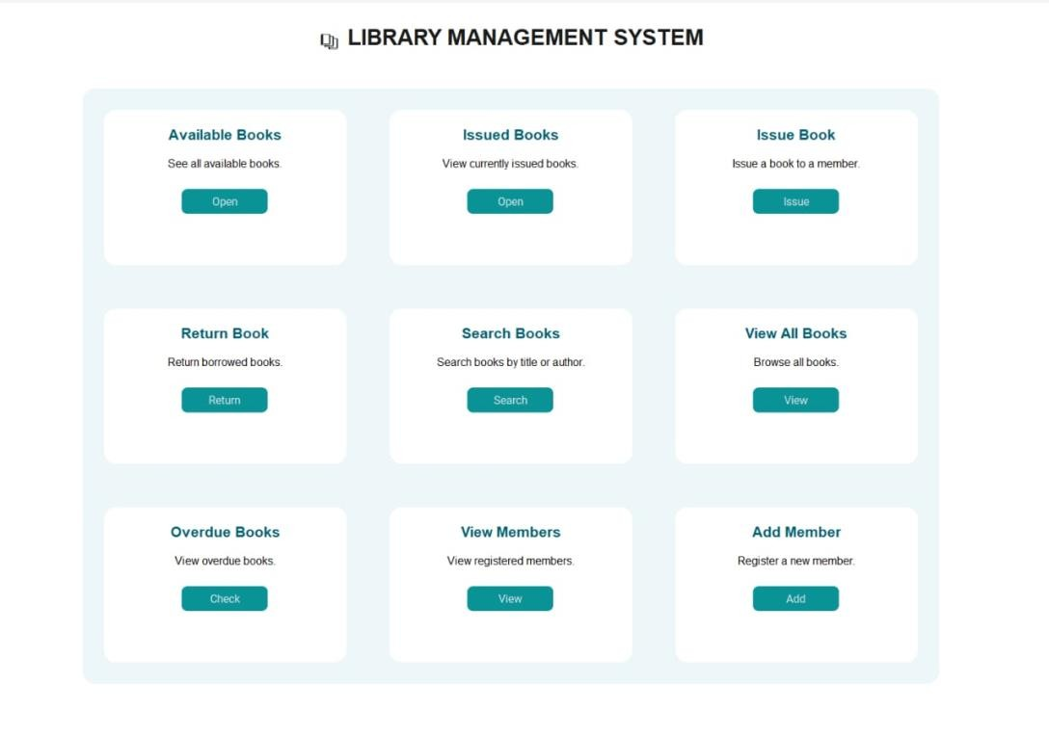
Fig 5.1 Introduction page
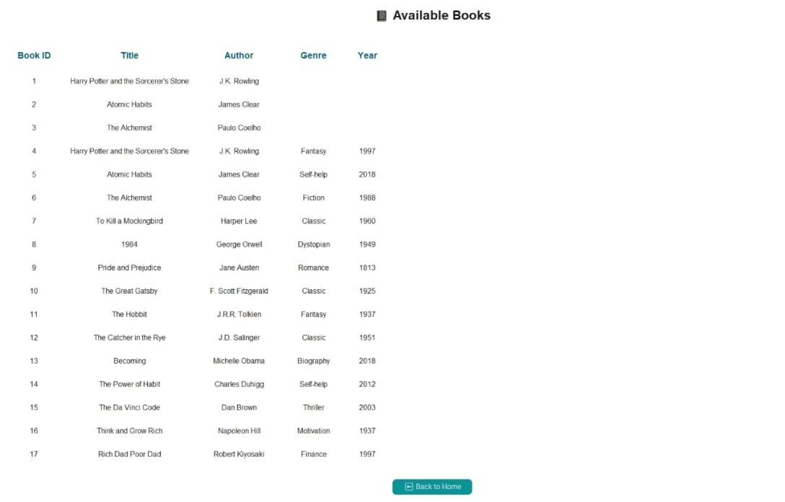
Fig 5.2 Available Books
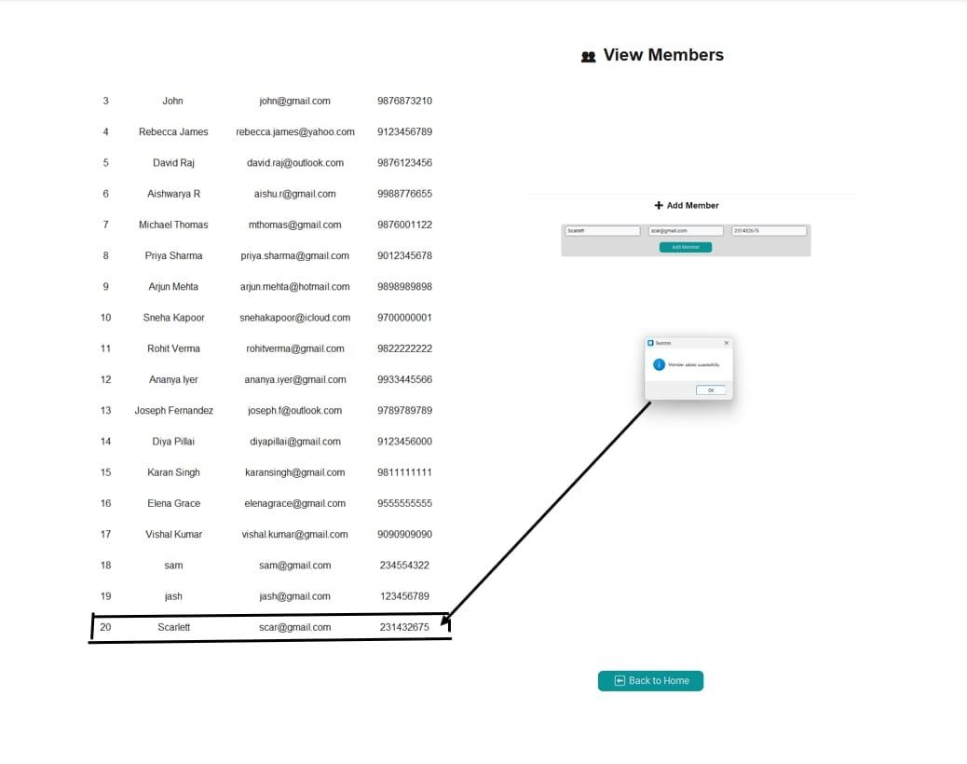
Fig 5.3 View Members

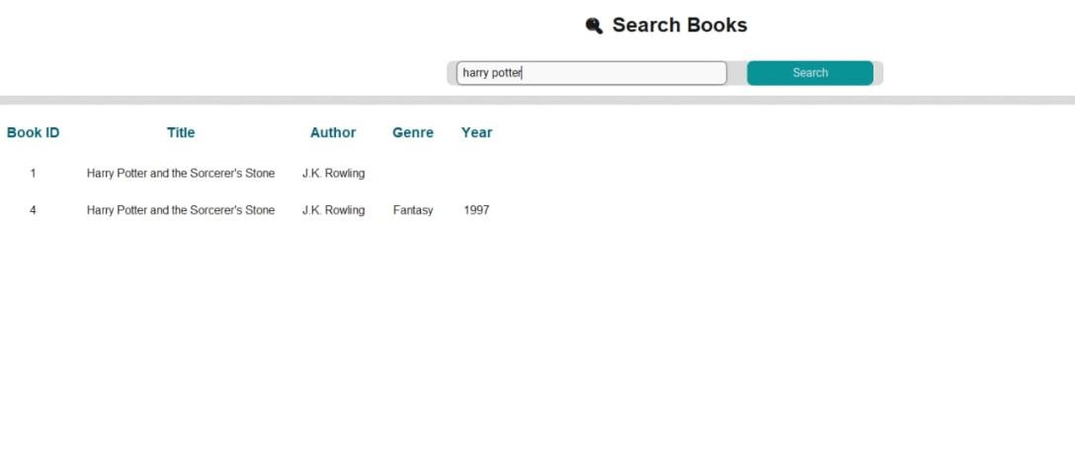
Fig 5.4 Search Books
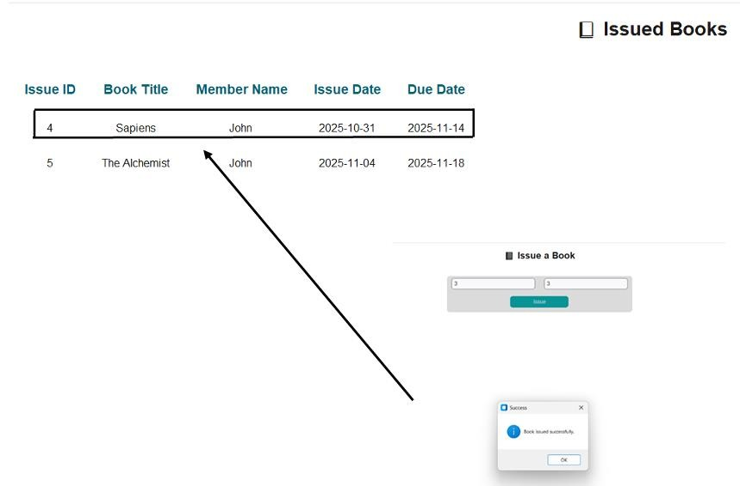
Fig 5.5 Issue Book
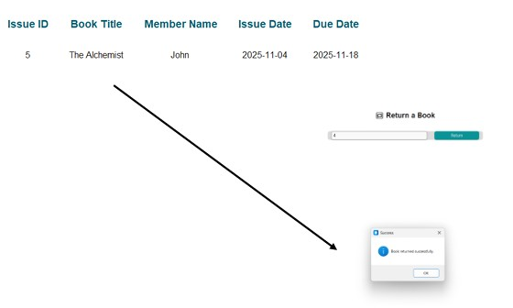
Fig 5.6 Return Book
Entity Relationship Diagram:

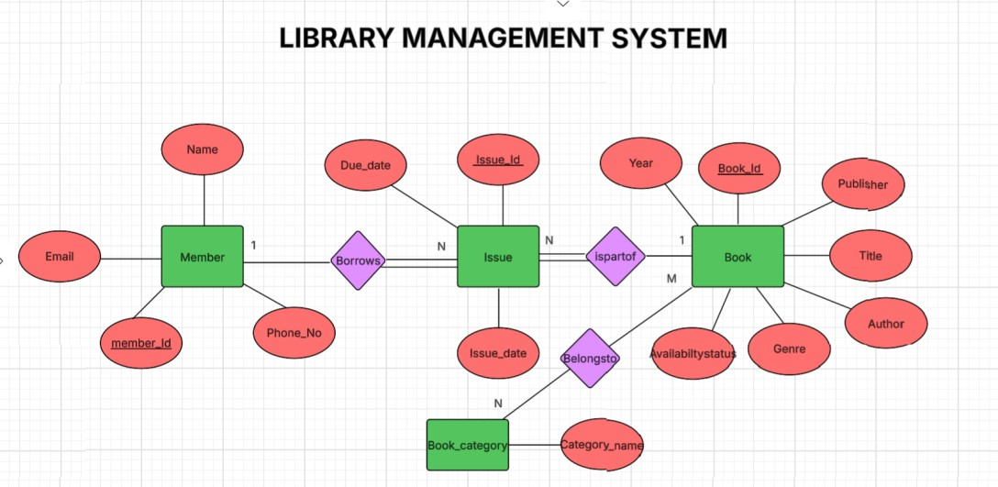

CHAPTER 6
CONCLUSION AND FUTURE ENHANCEMENT
The Library Management System successfully demonstrates the use of database management principles in real-world applications. It helps the librarian to automate the data easily into computer. The main aim of this Database system is to reduce human efforts. The Books and the Students are given a particular unique Id no, so that they can be accessed correctly without any errors. The problems which existed earlier have been removed to a large extent with the help of this MYSQL database software. The computerization of the library management will not only improve the efficiency but will also reduce human stress thereby indirectly improving human resources. It simplifies library operations by automating manual tasks, reducing human errors, and improving efficiency. Future enhancements could include user authentication, fine calculation for overdue books, and integration with online library systems.

REFERENCES
- https://www.researchgate.net/publication/378435639_Library_ma nagement_database_design_and_application
- https://www.researchgate.net/publication/266650310_The_Desig n_and_Implementation_of_Database_on_Library_Management_I nformation_System
- https://www.clausiuspress.com/assets/default/article/2023/05/15/a rticle_1684158036.pdf?utm_source=chatgpt.com
- https://www.geeksforgeeks.org/system-design/system-design-forlibrary-management/
- https://www.scribd.com/document/639582554/PROJECTREPORT-ON-LIBRARY-DATABASE-MANAGEMENT-
SYSTEM?utm_source=chatgpt.com

